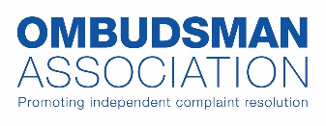

Declaration of Interests
2025-2026

NAME: Paul McFadden

I hereby declare the following interests (please state ‘None’ in each case where there are no interests).

Employment: Scottish Public Services Ombudsman. Public appointment for a fixed term of 8 years.

Interests in OA member organisations:
Scottish Public Services Ombudsman. No other active appointments or interests with other OA member organisations, although have previously been employed/appointed into senior roles with the Northern Ireland Public Services Ombudsman and Legal Ombudsman for England and Wales.
General business interests:

None.
Interests of close family members, close associates or persons living in the same household who have interests related to the OA’s business:

None.

Other matters to note:

None.

